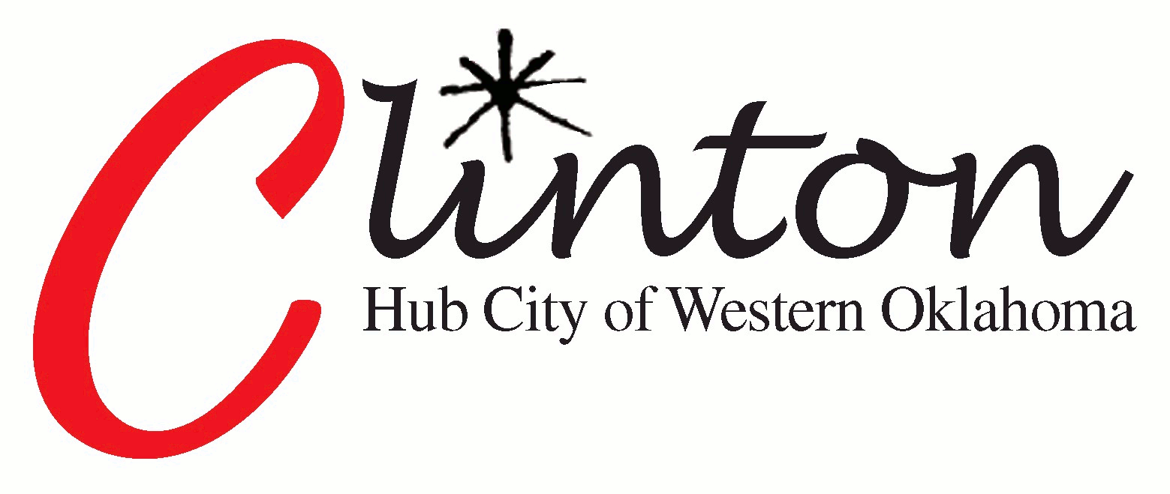
Agenda Commentary

Item Title/ Subject: Lead Service Line Inventory Report

Staff Source: Gene McCullough, Public Works Director

Date: November 17, 2023

History/Background Information: On August 4, 2022, EPA released Guidance for Developing and Maintaining a Service Line Inventory to support water systems with their efforts to develop inventories and to provide states with needed information for oversight and reporting to EPA. The guidance provides essential information to help water systems comply with the Lead and Copper Rule Revisions requirement to prepare and maintain an inventory of service line materials by October 16, 2024.
The Lead Service Line Inventory (LSLI) project is a critical initiative aimed at assessing and managing lead pipes within our public water distribution systems. These lead service lines (LSLs) can pose health risks, especially when they corrode and leach lead into our drinking water. The primary objectives of the LSLI project are as follows:
Identification and Documentation:
The LSLI aims to identify the location, material, and other pertinent information of service lines, including both lead service lines and galvanized service lines downstream of lead pipes.
By creating a comprehensive inventory, we can understand the extent of LSLs within our community.
Replacement Planning:
Armed with accurate data from the inventory, we will develop a strategic replacement plan for all lead service lines and those galvanized lines requiring replacement.
Our goal is to systematically replace these lines to safeguard public health and reduce exposure to lead.
Community Engagement:
Transparency and communication are key. We will actively engage with residents, providing information about the LSLI project, its progress, and the steps being taken to address lead exposure.
Prioritizing inventory development in disadvantaged communities and areas where children live and play is essential.
Federal Support and Funding:
The Environmental Protection Agency (EPA) has released guidance for developing and maintaining service line inventories, emphasizing best practices and public communication.
Recommendation:
Price/Cost: BUDGETARY ONLY: Approximately 4000 service meters @ $300 = $1,200,000.00
The OWRB has an approximately $25,000,000 pool annually for funding of these projects with 33% debt forgiveness loans. When the funds are depleted, municipalities and organizations can reapply the next year.

