All items on this agenda, including but not limited to any agenda item concerning the adoption of any ordinance, resolution, contract, agreement, or any other item of business, are subject to amendment, including additions and/or deletions. This rule will apply to every individual agenda item without exception, and without providing this same amendment language with respect to each individual agenda item. Such amendments should be rationally related to the topic of the agenda item, or the governing body will be advised to continue the item.

The governing body may adopt, approve, ratify, deny, defer, recommend, amend, strike, or continue any agenda item. When more information is needed to act on an item, the governing body may refer the matter to its City/Trust Manager, staff, attorney or to the recommending board, commission, or committee.

PUBLIC NOTICE OF A SPECIAL MEETING OF THE CLINTON HOSPITAL AUTHORITY
MONDAY, OCTOBER 16, 2023, 11:30 A.M. WEICHEL CONFERENCE CENTER CLINTON REGIONAL HOSPITAL

AGENDA

- CALL TO ORDER
If there is any potentially known conflict of interest relevant to a matter requiring action by the Board, the trustee(s) shall call it to the attention of the Board at this time and said trustee(s) shall not vote on the matter.

- BUSINESS ITEMS - Discussion, Consideration, and Possible Action

  - Medical Executive Committee By Laws
  - Contract for Emergency Department Services
  - Contract for Hospitalist Services Ill ADJOURN
Filed this 12th Day of October 2023. Posted on the bulletin board in the lobby of the Clinton City Hall and the lobby of the Clinton Regional Hospital October 12, 2023, at 11:30 a.m.

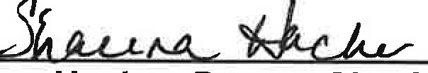
Shauna Hacker, Deputy City Clerk

